Course instructor:

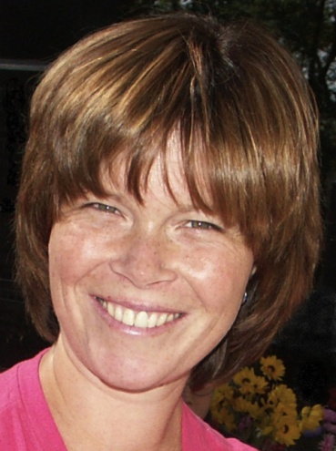
Martina Ježková, DPT
Martina Ježková completed her Physiotherapy Master’s degree at the Faculty of Physical Education and Sport, Charles University, Prague in 2001. Since, she has been working as a physiotherapist at the Rehabilitation Clinic, University Hospital Motol in Prague both at the outpatient and inpatient departments. In 2002, she became an instructor in rehabilitation, teaching both physiotherapy and medical students at the 2nd Faculty of Medicine, Charles University, Prague.
Specialized in the functional assessment and treatment of both adult and paediatric patients, she has completed numerous professional courses including the Brügger approach; functional assessment and treatment according to Mojžíšová; Klapp Crawling; and kinesiotaping.
A certified Vojta therapist since 2004, Martina has completed courses in Reflex Locomotion, “Vojta treatment approach for adult, children, and newborn patients”. Martina has, since 2004, served as a certified instructor in musculoskeletal techniques according to prof. Karel Lewit and since 2005, as an international certified instructor in Dynamic Neuromuscular Stabilization according to Kolar.
In her rehabilitation practice, Martina particularly focuses on the treatment of babies with cerebral palsy, children with central coordination disturbance, neurological patients and gynaecologic patients with functional sterility and urinary stress incontinence. She is certified Purna Yoga instructor, studiing Iyengar yoga. Specializing in the integration of Dynamic Neuromuscular stabilization into Yoga principles and practice.

